**DataSet2**

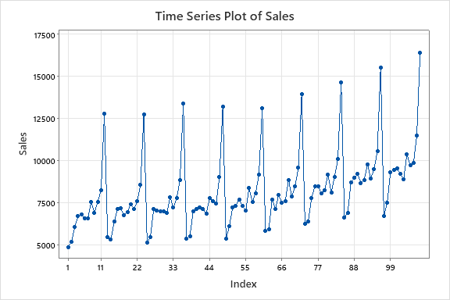

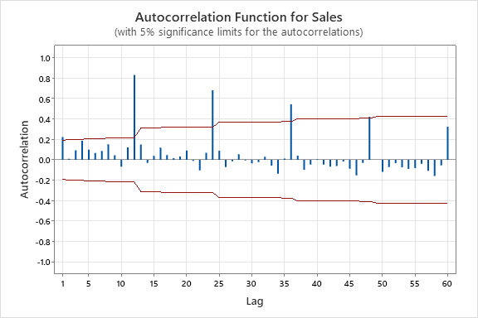

Autocorrelations

Lag ACF T LBQ

1 0.224179 2.33 5.58

2 0.011058 0.11 5.59

3 0.092695 0.92 6.57

4 0.185805 1.83 10.51

5 0.099326 0.95 11.65

6 0.067212 0.64 12.17

7 0.086796 0.82 13.06

8 0.152932 1.43 15.84

9 0.044287 0.41 16.07

10 -0.067845 -0.62 16.63

11 0.121508 1.11 18.44

12 0.831281 7.52 103.95

13 0.149945 0.95 106.77

14 -0.031031 -0.19 106.89

15 0.039137 0.25 107.08

16 0.119334 0.75 108.92

17 0.047609 0.30 109.22

18 0.016285 0.10 109.25

19 0.032572 0.20 109.39

20 0.090951 0.57 110.51

21 -0.009492 -0.06 110.52

22 -0.103987 -0.65 112.02

23 0.067990 0.42 112.66

24 0.682681 4.21 178.58

25 0.088348 0.47 179.69

26 -0.070525 -0.38 180.41

27 -0.013901 -0.07 180.44

28 0.055690 0.30 180.90

29 -0.007075 -0.04 180.91

30 -0.034994 -0.19 181.10

31 -0.022044 -0.12 181.17

32 0.029891 0.16 181.31

33 -0.056559 -0.30 181.82

34 -0.136965 -0.73 184.83

35 0.012668 0.07 184.86

36 0.543957 2.88 233.68

48 0.421836 2.05 279.19

60 0.324552 1.50 323.46

Seasonal difference

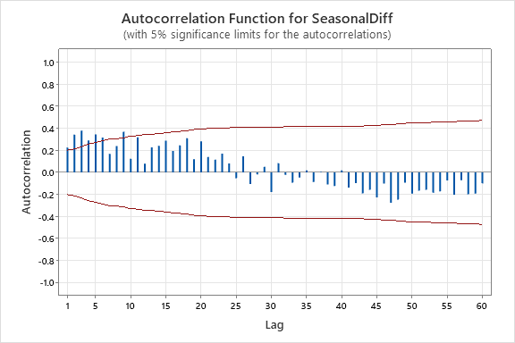

Still the series is non stationary. Trend difference is required.

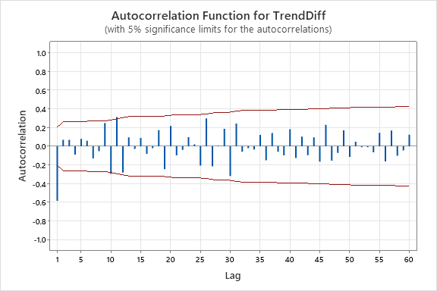

Autocorrelations

Lag ACF T LBQ

1 -0.583848 -5.69 33.42

2 0.069639 0.52 33.90

3 0.068011 0.51 34.36

4 -0.088708 -0.66 35.16

5 0.079062 0.59 35.80

6 0.059175 0.44 36.16

7 -0.129467 -0.96 37.92

8 -0.052700 -0.39 38.21

9 0.249519 1.83 44.88

10 -0.296670 -2.10 54.42

11 0.312221 2.11 65.12

12 -0.281747 -1.82 73.93

13 0.094644 0.59 74.94

14 -0.028991 -0.18 75.03

15 0.089724 0.56 75.96

16 -0.080870 -0.50 76.72

17 -0.019516 -0.12 76.77

18 0.172699 1.07 80.34

19 -0.244918 -1.50 87.61

20 0.216404 1.29 93.36

21 -0.097602 -0.57 94.55

22 -0.038009 -0.22 94.73

23 0.097016 0.57 95.94

24 0.020581 0.12 95.99

25 -0.207269 -1.21 101.65

26 0.298048 1.71 113.51

27 -0.215283 -1.20 119.79

28 0.005927 0.03 119.80

29 0.185802 1.02 124.62

30 -0.318069 -1.73 138.96

31 0.243585 1.28 147.50

32 -0.059110 -0.31 148.01

33 -0.020894 -0.11 148.08

34 -0.034981 -0.18 148.26

35 0.121467 0.63 150.53

36 -0.150061 -0.77 154.05

37 0.141855 0.73 157.24

38 -0.059742 -0.30 157.82

39 -0.098005 -0.50 159.40

40 0.183346 0.93 165.03

41 -0.125664 -0.63 167.73

42 0.103667 0.52 169.60

43 -0.095270 -0.48 171.20

44 0.095776 0.48 172.86

45 -0.164044 -0.82 177.82

46 0.229822 1.13 187.75

47 -0.154251 -0.75 192.32

48 -0.071491 -0.35 193.32

49 0.170579 0.82 199.15

50 -0.113123 -0.54 201.77

51 0.049140 0.24 202.28

52 -0.009457 -0.05 202.30

53 -0.009400 -0.04 202.32

54 -0.064862 -0.31 203.26

55 0.143806 0.69 208.03

56 -0.161944 -0.77 214.22

57 0.169236 0.80 221.17

58 -0.100757 -0.47 223.70

59 -0.044165 -0.21 224.20

60 0.123410 0.58 228.21

Stationary

PACF

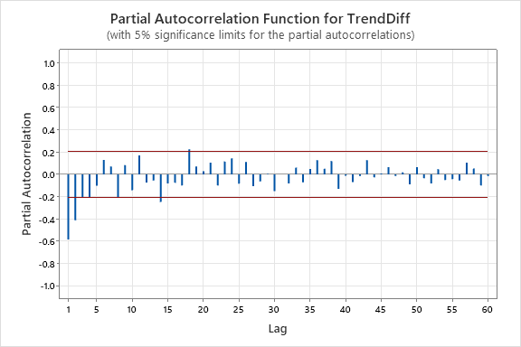

Partial Autocorrelations

Lag PACF T

1 -0.583848 -5.69

2 -0.411517 -4.01

3 -0.209793 -2.04

4 -0.207444 -2.02

5 -0.101668 -0.99

6 0.128923 1.26

7 0.071306 0.70

8 -0.202772 -1.98

9 0.082228 0.80

10 -0.142448 -1.39

11 0.171175 1.67

12 -0.073170 -0.71

13 -0.055404 -0.54

14 -0.246570 -2.40

15 -0.080412 -0.78

16 -0.074456 -0.73

17 -0.099545 -0.97

18 0.224981 2.19

19 0.071503 0.70

20 0.028890 0.28

21 0.105540 1.03

22 -0.098713 -0.96

23 0.114664 1.12

24 0.144021 1.40

25 -0.083307 -0.81

26 0.111634 1.09

27 -0.106106 -1.03

28 -0.062491 -0.61

29 0.003497 0.03

30 -0.150716 -1.47

31 -0.000527 -0.01

32 -0.080689 -0.79

33 0.060517 0.59

34 -0.070640 -0.69

35 0.047918 0.47

36 0.127175 1.24

37 0.050634 0.49

38 0.120603 1.18

39 -0.130360 -1.27

40 -0.012772 -0.12

41 -0.068144 -0.66

42 -0.014823 -0.14

43 0.127243 1.24

44 -0.026192 -0.26

45 0.007407 0.07

46 0.064761 0.63

47 -0.013319 -0.13

48 0.019003 0.19

49 -0.089332 -0.87

50 0.065400 0.64

51 -0.034985 -0.34

52 -0.081258 -0.79

53 0.046632 0.45

54 -0.051603 -0.50

55 -0.043539 -0.42

56 -0.054539 -0.53

57 0.104934 1.02

58 0.052678 0.51

59 -0.098722 -0.96

60 -0.014836 -0.14

Tentative Model

SARIMA (0,1,1)(0,1,0)12

Forecasts

Lead: No. of forecasting values

Origin: Starting point

Ex: If the origin is 10, it gives the forecasting value from 11th.

MAPE = (1/12)*SUM(ABS('Actual'-'FORE')/('Actual'))*100

Accuracy = 100 – MAPE

= 100-((1/12)*SUM(ABS('Actual'-'FORE')/('Actual'))*100)